Configuring the Application Processor

## Overview:

The application processor is a tool for importing loan applications from 3rd parties. The tool converts application information from a delimited file or a SQL query into the AccuAccount importer xml and runs importer. In Legacy Import mode, importer creates/updates the customer and loan records and the application processor inserts the application records.

Once the Application Processor is installed it must be configured. There are three configuration files that the interface utilizes. These files are “Config.xml”, “FieldMap.xml”, and “Rules.xml”.

In the installation folder for the application processor there are template files for these configuration files. Copy the template files and remove “_template” from the file names as shown below.

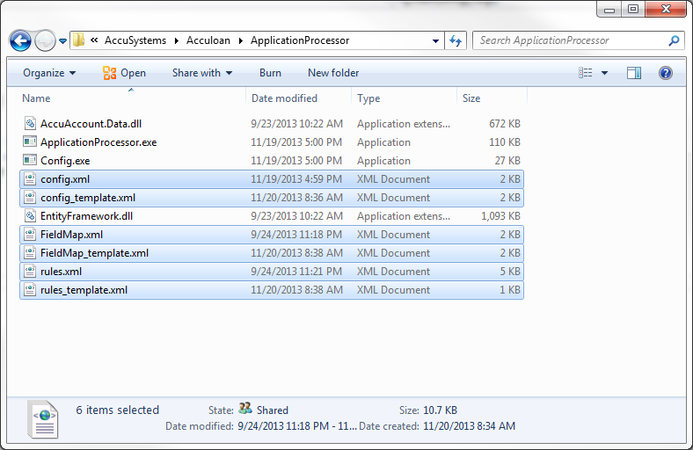

The config.xml and fieldmap.xml can be configured manually by editing the xml files, or by using the config.exe utility. The rules.xml should only be configured using the config.exe utility.

## Config.exe

The config.exe utility is an interface for configuring the application processor. The three xml files are configured by clicking on the respective button:

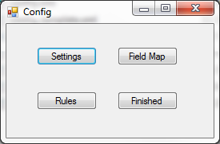

Settings – config.xml

Field Map – fieldmap.xml

Rules – rulex.xml

## Settings – config.xml

Click the settings button to edit the config.xml file. This will open the configuration editor.

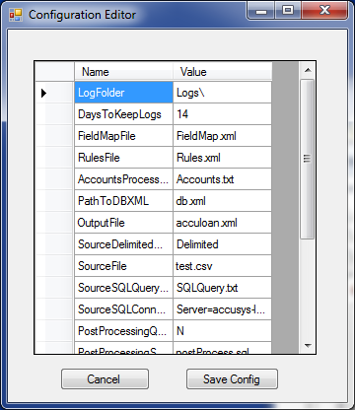

Edit the Value column for each of the configuration elements as detailed below. When finished be sure to click the “Save Config” button or changes will be lost.

|  |  |
| --- | --- |
| Element Name | Description |
| LogFolder | The folder name for log files. This folder will be created within the application processor folder. |
| DaysToKeepLogs | The number of days to retain logs in the log folder |
| FieldMapFile | The file name of the field map configuration file. This file should be in the same folder as the application. |
| RulesFile | The file name of the rules configuration file. This file should be in the same folder as the application. |
| AccountsProcessedLogFile | The file name of the accounts processed log. This file contains a log of the account numbers which were processed. |
| OutputFile | The importer xml file. This file should typically be named acculoan.xml and should be located in the importer folder. |
| SourceDelimitedSqlXml | Sets the source of the import data. Valid options are:  Delimited – a delimited file, a schema.ini file must exist for a delimited file  SQL – The source records will be retrieved from a SQL database. A sql query file must exist.  XML – This option is not implemented at the time of this document |
| SourceFile | The file name to use for a Delimited source file. |
| SourceSQLQueryFile | The file name of the SQL query for a SQL source |
| SourceSqlConnectionString | The SQL connection string for a SQL source |
| PostProcessingQueryYN | Indicates whether to run a post processing against the source database. In some cases a third party may have an export flag for applications in their database. Once those applications have been processed this option can be used to clear that flag. |
| PostProcessingSqlQueryFile | The file name of the post processing query. This file contains the query to be used when PostProcessingQueryYN is set to “Y”. The application processor will replace any occurance of “%%A” with a comma separated list from the “PostProcessingField”. A typical post processing query would be “update [table] set ExportFlag = 0 where ApplicationNumber in (%%A)” |
| TestSourceModeYN | With a value of “Y”, the application processor will read the source data and write it to a comma separate file. No other processing will occur. This can be useful for viewing the data returned from a SQL source. |
| ProcessExistingAccounts | A Y/N value that determines whether accounts that already exist in the AccuAccount database will be included in the import xml file. |
| CollateralsYN | A Y/N value that indicates whether collaterals are included in the source data. |
| ProcessMTEs | A Y/N value that indicates whether the application processor should do MTE lookups |
| ImporterPath | The path to the AccuAccount.Importer.exe. |
| UseLegacyImport | A Y/N value that indicates whether the application processor should insert application records. When the value is set to Y, application processor will launch importer to allow customers and accounts to be created. It will then insert the application records |

## Field Map – fieldmap.xml

Click the Field Map button to edit the fieldmap.xml file. This will open the configuration editor. Edit the Value column for each of the field map elements as detailed below. When finished be sure to click the “Save Config.xml” button or changes will be lost.

The field map file maps source data fields to their corresponding import fields. The value of the element should be the name of the source column. Required fields can be assigned default values using the rules configuration.

|  |  |
| --- | --- |
| Customer Fields | Required / Optional |
| customerNumber | Requried |
| taxId |  |
| customerName | Required |
| businessName |  |
| customerFirstName |  |
| customerMiddleName |  |
| customerLastName |  |
| customerTypeCode | Required |
| bankCode | Required |
| employee |  |
| customerBranch | Required |
| customerOfficerCode | Required |
| address1 |  |
| address2 |  |
| city |  |
| state |  |
| zipCode |  |
| homePhone |  |
| workPhone |  |
| mobilePhone |  |
| fax |  |
| email |  |
| classificationCode |  |
| customerStatus | Required |
| Loan Fields | Required / Optional |
| loanNumber | Required |
| collateralLoanNumber | Required for collaterals |
| collateralAddenda | Required for collaterals |
| parentLoanNumber | Required for collaterals |
| accountClass | Required |
| loanOfficerCode | Required |
| loanTypeCode | Required |
| collateralLoanTypeCode | Required for collaterals |
| loanStatusCode | Required |
| loanClosed |  |
| loanAmount |  |
| loanOriginationDate |  |
| loanDescription |  |
| collateralDescription |  |
| borrowerType | Required |
| owningCustomerNumber |  |
| loanBranch | Required |
| coreClassCode |  |
| coreCollCode |  |
| coreCollateralCode |  |
| corePurposeCode |  |
| coreTypeCode |  |
| commitmentAmount |  |
| coreNaicsCode |  |
| loanMaturityDate |  |
| loanClassificationCode |  |
| Application Fields | Required / Optional |
| applicationDate |  |
| creditAnalysisStatus |  |
| requestedAmount |  |
| primaryCollateralValue |  |
| FICO |  |
| valuationDate |  |
| interestRate |  |
| probability |  |
| estimatedCloseDate |  |
| assignedLender |  |
| assignedLenderType |  |
| assignedAnalyst |  |
| assignedAnalystType |  |
| assignedLoanProcessor |  |
| assignedLoanProcessorType |  |
| applicationLocked |  |
| Approval Fields | Required / Optional |
| approvalStatus | Required |
| originatingUser | Required |
| assignedApprover |  |
| assignedApproverType |  |
| Generic Fields | Generic fields are not mapped to import fields but can be used in rule processing. |
| generic1 |  |
| generic2 |  |
| generic3 |  |
| generic4 |  |

## Rules – rules.xml

Click the Rules button to edit the rules.xml file. This will open the rules editor. Edit the rules as detailed below. When finished be sure to click the “Save” button or changes will be lost.

Rules are used to manipulate the source data before writing the import xml. This can be used to set default field values, make calculations etc.

**Adding Rules:**

1. Change the Sequence number if necessary
2. Setup the condition
   1. Select the field to evaluate
   2. Select the operator to use in the evaluation
      1. Use the “Always” operator to bypass the condition and always manipulate the field
   3. Select the value to use in the comparison
3. Select the action to be taken
   1. If the condition is true the action will be applied
   2. The field selected in the condition, will be the field manipulated for all actions except “Set Other Field to:”
4. Assign parameter values
   1. The parameter fields become available based on the action to be taken
5. Click the Add Rule button

The following is a sample of configured rules

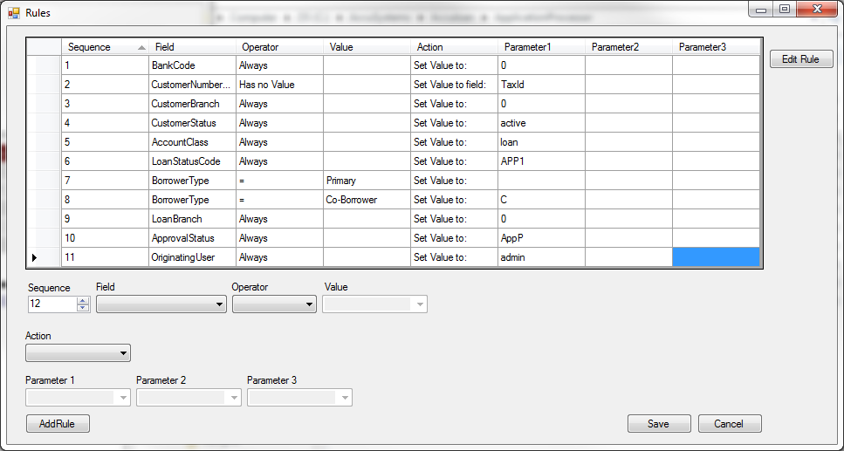

Rules are processed in sequential order. When building rules remember that any previous rules will already be applied.